

YEAR 12 PHYSICS PRACTICAL ASSESSMENT

CIRCULAR MOTION

NAME: ______________________________ Mark: ________________/32

Time allowed: 55 mins

A talented physics student conducted an experiment investigating circular motion. The conical pendulum apparatus is shown below. Inspect the diagram & labels carefully.

The stopper was whirled in a circle and the radius of the circle was kept at a constant value of
0.600 m.

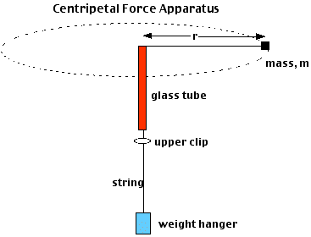
Mass supplying the centripetal force (F_{c})
alligator clip or sticky tape
stopper (mass = m)

The results obtained are shown on the table on the next page:
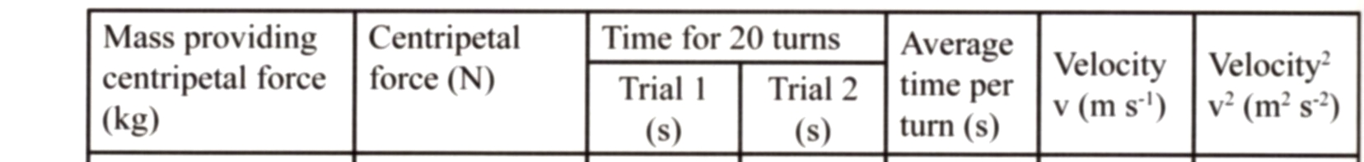

0.200 14.9 15.2

0.250 14.2 13.1

0.300 12.9 11.7

0.400 10.8 10.3

0.450 10.1 10.2

- Complete the table of results above. (4 marks)

- The experiment contained design elements to improve the following:

- Accuracy (ensuring the measured value is close to the true value),
- Precision (reducing variability among individual measurements), and
- Reliability (ensuring repeatability of results under identical circumstances).
- Validity (ensuring that the experiment is measuring what it is intended to measure by controlling appropriate variables).

Detail one way each of the above were addressed in this experiment:

(4 marks)

- On the graph paper provided, plot the data of centripetal force versus velocity squared. Include a line of best fit.
(5 marks)

- Use the graph from Q3 to determine the mass of the rubber stopper (show all working below and clearly explain any data taken from the graph or table): (4 marks)

- In reality, the fishing line will not rotate in a perfectly horizontal circle.

Glass tube

Stopper

Fishing line

Masses

- Draw fully labeled arrows on the diagram above to represent all forces on the stopper. (2 marks)

- What force, or component of force, balances the weight of the stopper? (1 mark)

- In this experiment, it was assumed that the tension in the fishing line is equal to the centripetal force. If the fishing line makes an angle to the horizontal as shown above, this will not be true. If the angle between the string and the horizontal is 5°, use simple trigonometry to show that the difference between T and Fc is still less than 1% (you should not need to calculate T and Fc numerically - include any relevant diagrams in your answer): (3 marks)

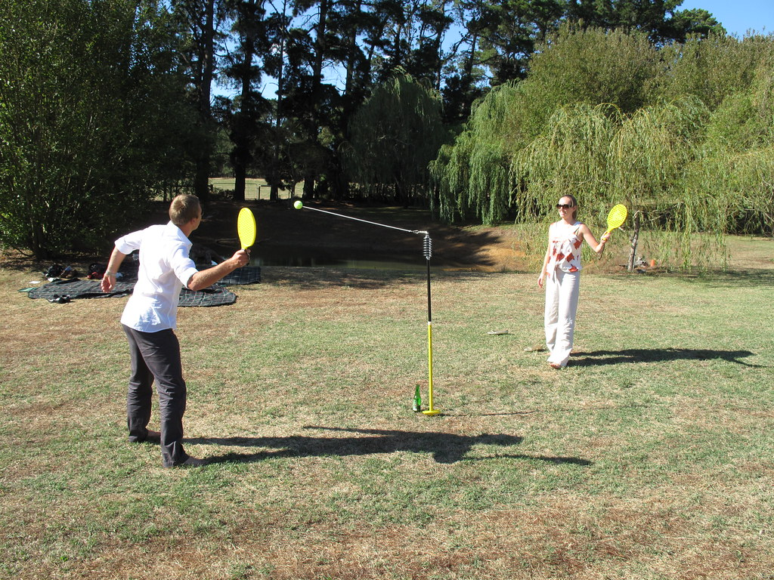
- In a real-world application of the conical pendulum: You are playing totem tennis with a friend and hit the ball so that it begins to travel in a circular horizontal path. If rope length is 1.2 meters, the ball has a speed of 3.7 m/s, a mass of 0.42 kg, and its (presumed weightless) rope makes a 49⁰ angle with the pole, find the tension force that the rope exerts on the ball. Include any relevant diagrams in your answer. (5 marks)


- You are at the carnival and decide to go on the swing ride. It is a high rotating platform from which the swing seats hang like pendulums. As the platform begins to turn, your swing’s chain does not stay perpendicular to the ground, but angles out from the vertical. If your distance from the center of rotation is 8.50 m, and you go around once every 12.0 sec, what angle does your swing make with the vertical? Include any relevant diagrams in your answer. (4 marks)

END OF VALIDATION

(Spare graphing page overleaf if required)

